Banker Space
The Banker Space is where a user (a Banker) can access all data that are relevant to his or her work. The Banker Space is the start page when a user launches the eNterprize application.

The Banker Space has 6 tabs:
- My Customers
- My BUID
- My Submissions
- My AMV
- My Covenants
- My Feedback
These tabs are described in following sections.

My Customers Tab
In this screen, the user can select a Banker in the BUID hierarchy to view his Aggregation Groups or Individual Customers. He can then select a Customer or Aggregation Group, to view/edit details of this Customer or Aggregation Group.

User Interface
Depending on selected view, the screen will be changed accordingly.
Aggregation Group View: displays all Aggregation Groups and its Customers (Customers belongs to Aggregation Group)
Customer View: displays all Individual Customers who do not belong to any Aggregation Group

Aggregation Group View
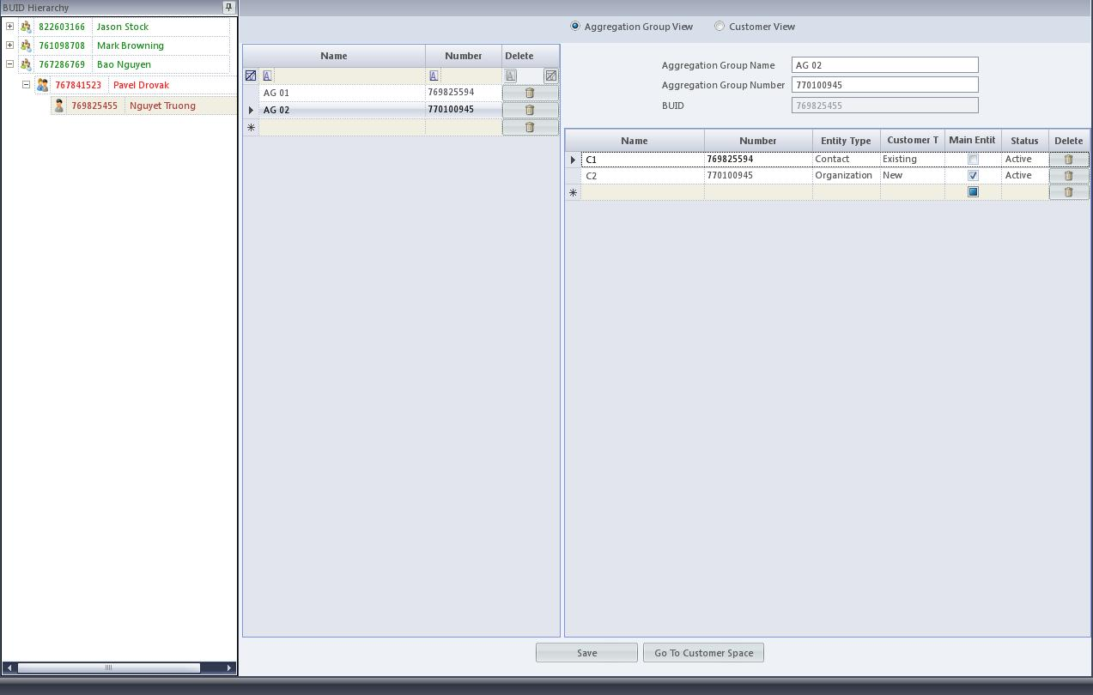

Customer View
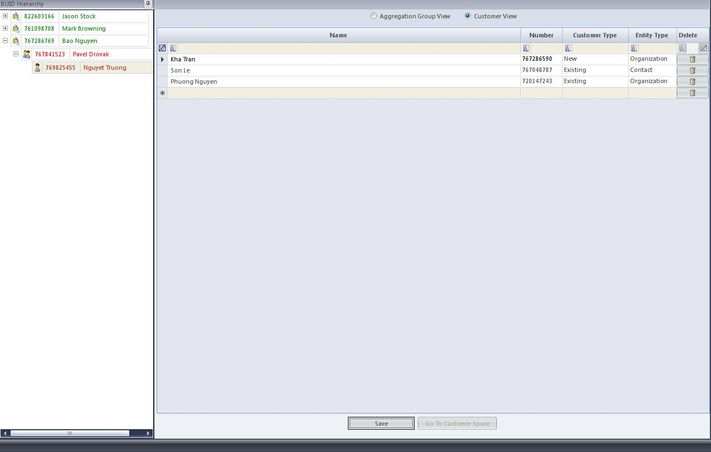

Elements

Aggregation Group View
Element Name | GN | Type | Format | Required  [Y/N] | Description
BUID Hierarchy |  | I/O | Tree View |  | - Refer to section Error: Reference source not found Error: Reference source not found for more details.
Aggregation Group View |  | I | Radio Button |  | To switch to Aggregation Group View  This view is selected as default.
Customer View |  | I | Radio Button |  | To switch to Customer View
Aggregation Group List |  |  |  |  | All Aggregation Groups belong to selected Banker in BUID Hierarchy Tree View
Name |  | I | Textbox |  | Aggregation Group name
Number |  | I | Integer |  | Aggregation Group number  Rules: Refer to Error: Reference source not found Error: Reference source not found for information.
Delete |  | I | Button |  | To delete selected Aggregation Group  Warning message: when the button is pressed, system will prompt user the message:  “Are you sure you want to delete the selected Aggregation Group?”  Option: Yes, No  - Yes: Proceed the deletion action.  - No: Cancel the deletion action.
Aggregation Group’s Information |  |  |  |  | Details of a selected Aggregation Group
Aggregation Group Name |  | O | Textbox |  | Aggregation Group name
Aggregation Group Number |  | O | Integer |  | Aggregation Group number
BUID |  | O | Integer |  | Banker’s BUID
Customer List |  |  |  |  | Customers belong to selected Aggregation Group
Name |  | I | Textbox |  | Customer name
Number |  | I | Integer |  | Customer number  Rules: Refer to Error: Reference source not found Error: Reference source not found for information.
Customer Type |  | I | Dropdown List |  | Options:  - New  - Exisiting
Entity Type |  | I | Dropdown List |  | Options:  - Contact  - Organization
Main Entity |  | I | Checkbox |  | Rules: Only one customer can be the main entity in an Aggregation Group at a time.
Status |  | I | Dropdown List |  | Options:  - Active  - Closed
Delete |  | I | Button |  | To delete selected Customer from an Aggregation Group  Warning message: when the button is pressed, system will prompt user the message:  “Are you sure you want to delete the selected Customer?”  Option: Yes, No  - Yes: Proceed the deletion action  - No: Cancel the deletion
Save |  | I | Button |  | To save updated information of an Aggregation Group/Customer  Rule: Changes need to be saved per Aggregation Group. If the user does not save changes and navigate to another Aggregation Group, previous changes will be discarded.
Go to Customer Space |  | I | Button |  | Go to Customer Space – Client Profile Tab (refer Error: Reference source not found Error: Reference source not found)

Customer View
Element Name | GN | Type | Format | Required  [Y/N] | Description
BUID Hierarchy |  |  |  |  | Refer to section Error: Reference source not found Error: Reference source not found for more details.
Aggregation Group View |  | I | Radio Button |  | To switch to Aggregation Group View
Customer View |  | I | Radio Button |  | To switch to Customer View  This view is selected
Customer List |  |  |  |  | List of Individual Customers who do not belong to any Aggregation Group
Name |  | I | Textbox |  | Customer name
Number |  | I | Integer |  | Customer number  Rules: Refer to Error: Reference source not found Error: Reference source not found for information.
Customer Type |  | I | Dropdown List |  | Options:  - New  - Existing
Entity Type |  | I | Dropdown List |  | Options:  - Contact  - Organization
Status |  | I | Dropdown List |  | [Note: currently, this field does not show in Customer View]  Options:  - Active  - Closed
Delete |  | I | Button |  | To delete selected Individual Customer.  Warning message: when the button is pressed, system will prompt user the message:  “Are you sure you want to delete the selected Customer?”  Option: Yes, No  - Yes: Proceed the deletion action.  - No: Cancel the deletion action.
Save |  | I | Button |  | To save updated information of Customers
Go to Customer Space |  | I | Button |  | Go to Customer Space – Client Profile Tab (refer Error: Reference source not found Error: Reference source not found)

Business Rules
- Filtering function: is available at
Aggregation Group List (Aggregation Group View)
Customer List (Individual Customer View)
Filtering function allows user to filter the list with following expressions:
Equals
Does not equal
Less than
Less than or equal to
Greater than
Greater than or equal to
Like
Matches Regular Expression
Starts with
Contains
Ends with
Does not start with
Does not contain
Does not end with
Does not match
Not Like
- A customer can belong to more than on Aggregation Group at a time.
- When adding an existing customer to an Aggregation Group by entering the customer’s number, system will auto-populate the remaining of the customer’s details.

